Going My Way?

**2014 WOMEN’S RETREAT**

**Cost: $20/person**

**September 5 and 6**

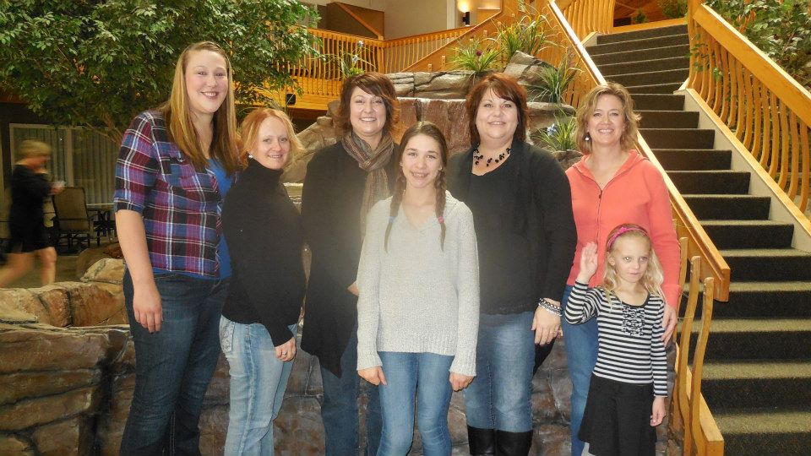

**WENDE**

**JENNESS**

WORSHIP LEADER

&

pastor’s wife in Greybull, WY.

**PATRICIA MONTALVO**

GUEST SPEAKER

&

pastor’s wife in

Casper, WY.

**MOUNTAIN TOP BAPTIST ASSEMBLY**

**on CASPER MOUNTAIN**

**Women of all ages will enjoy this event!!**

Mail registration to

**Debbie Zastrow 2855 E 10th St Casper WY 82609**

For more information call

**Beth Williams at 307-267-3092 or Jean Brown at 307-234-3594**

For My thoughts are not your thoughts, neither

are your ways My ways,” declares the Lord.

*Isaiah 55:8 (NIV)*